**Easy Start with Programmatic Mobile Advertising**

Begin with adding some motivation by considering money and why the topic is worth launching to your business. In March 2021, Statista Research Department, one of the trusted data reports providers, showed that in 2020, the share of spending aimed for programmatic mobile advertising stood at 83.3 percent. This value means billions of U.S. dollars, and by the way, continuously grows. The forecast expects 95 billion U.S. dollars as investments to all the programmatic ads in the coming 2022.

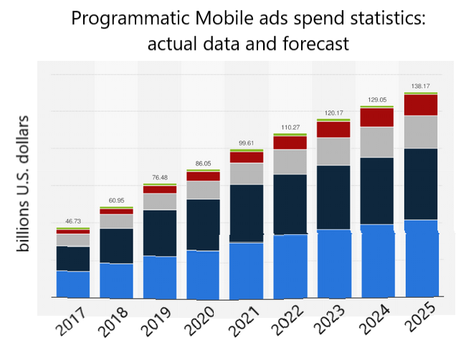

The Pandemic made marketers go online to communicate with their target auditory often using a [programmatic advertising](https://smartyads.com/blog/what-is-programmatic-advertising/) platform. When you see the trends of user behavior, the balls are in your court.

What is the next right step to take?

As an advertiser, you should pick a Demand-Side Platform (DSP). That is the best tool to conquer the attention of consumers and promote your services or goods. DSP is an automated programmatic system for starting, running, and managing ad campaigns. Practically, it takes the form of a personal account or private marketplace where you can do that in a cost-effective and data-driven manner. You set up the parameters of your desirable targeted viewers and add the ad creatives. The rest of the invisible work is performed automatically, and you may check up real-time reports on your performance to make adjustments and retarget.

What about the "automatic" part in programmatic advertising?

Although it may seem a bit complicated, the programmatic advertising platform operates faster than a fraction of a second. Furthermore, the advertiser provides the DSP with an array of information about the ad campaign, the desirable ad format, size, targeting specifics. Thus, the DSP knows the preferable impression to take.

The heart of DSP consists of real-time bidding technology. A media buyer offers bids for ad impressions during the real time bidding auction. The highest suggested price wins this contest of programmatic [media buying](https://smartyads.com/programmatic-media-buying). The SSP (Supply-Side Platform), in its turn, also provides some specific parameters about potential viewers, their age, gender, preferences, and so on. In addition, SSP notifies if the media is going to be delivered on-site or in-app.

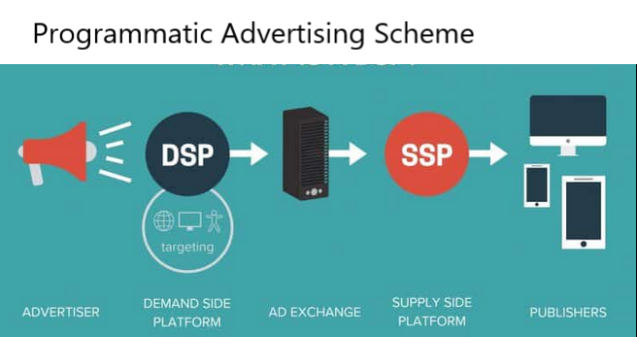

In that way, the DSP connects the advertiser's creatives with the ad exchanges, thousands of websites, and mobile programmatic apps to represent them to the final consumer. Even more, when the ad campaign is released, your DSP will know if the bid is high enough to be accepted or there is a necessity to increase the price to reach the targeted viewer. The platform will notify the admin about it. Programmatic media buying provides an advertiser with numerous shots to test target audiences and check marketing strategies.

Mobile DSP

The title mobile DSP is widespread, although advertisers manage mobile inventories in the same old DSP that uses the real time bidding (RTB) principle. There is no separate entity for programmatic advertising mobile DSP.

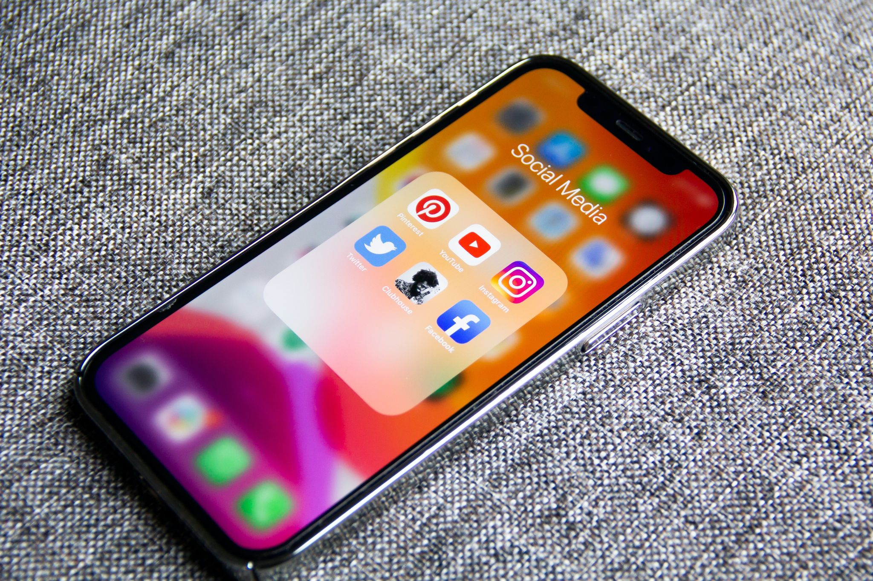

To support the course of massive moving online, developers offer comprehensive ways to contact people via mobile advertising space with portable tablets or smartphones. The idea is to set up mobile campaigns to deliver personalized messages (mobile videos, banners, natives, and other options) in real-time to the in-app and the mobile web. The difference between these notions is that the in-app ads occur to a user during any mobile application usage; mobile web ads are displayed in smartphone browsers. Thus, the mediated interface of [mobile DSP](https://smartyads.com/blog/everything-you-need-to-know-about-mobile-dsp/) is the only different thing compared to the desktop DSP environment.

[What is a demand-side platform](https://smartyads.com/blog/what-is-a-dsp-demand-side-platform) for mobile?

After revealing some theoretical information related to mobile programmatic advertising, we provide you with practical tips to use in your everyday routine. Whenever you decide to select mobile DSP for your business, check up the following:

* The DSP vendor technical capacities

You should know as much as possible about your potential DSP architecture. With the advanced platform, you will control tons of information from different supply-side platforms (websites, browsers, apps, devices, and locations). In the same manner, you will provide an unlimited number of data arrays for your targeted audiences and require launching numerous ad campaigns simultaneously. As well as cooperate with various exchanges and networks. Make sure the DSP vendor is powerful to handle all of your tasks.

* Detailed audience segmentation

The perfect mobile programmatic advertising DSPs outspread opportunities to arrange audiences. Indicate the details of behavioral attributes that are the most interesting to you, meaning geolocation, demographic and contextual properties, operational system, and type of smartphone. Set up the final destinations for the ads, if it is in-app or mobile web. Whatever you need, even IP, GPS coordinates, dayparting, and specific categories of mobile apps.

* Existence of popular inventories and breaking ground ad formats

Currently, there are many known types of ads, yet the industry develops and offers new ways. Smartyads programmatic advertising DSP for mobile offers advertisers to try and test rich media, mobile video units, native ad placements, dynamic and interstitial ads, and others. Make your viewers' watching experience more exciting by implementing interactive ads. They will like it!

* Real-time reports

Keep in touch with your statistics at any time. Track your performance and get ideas on what can be improved or changed. Clarify the frequency of information updates with the vendor and the possibility to export the data.

* Provided high security

Your DSP account is the inevitable part of your marketing. That is why it is crucial to be aware of all the malfunctions and alarms. With the Smartyads guaranteed brand safety, you get traffic of the highest quality, antifraud scanning, and detection of fake clicks. You will also check the number of real people (not robots!) who saw your advertisements.

* Qualified and professional assistance

Last but surely not least, pick a service that can offer you a helping hand by a personal account manager. Demand Side Platforms are [self serve advertising platform](https://smartyads.com/self-serve-advertising-platform)s that suggest all the tools to work with ad campaigns on your own. However, it is better to optimize ads together with a knowledgeable and experienced person.

All of the abovementioned advantages of Mobile DSP are present in programmatic advertising DSP from Smartyads. The platform will provide you with the best service. Register and give it a try to enlarge your business popularity and make new clients!

